

# **An incubated co-working space for technology innovation**

**Short Report Document**

|  |  |
| --- | --- |
| **TEAM NAME** | **CONQUERORS** |
| **TOPIC** | **WEB DEVELOPMENT** |
| **DATE** | **24/05/2015** |
| **PROJECT DIRECTOR** | **MALUSI GCAKASI** |
| **TEAM MEMBERS** | **XOLA ZOYA**  **NTOMBI GUBEKA**  **BONGIWE NGQOKOMA** |

**REPORT**

**WEB DEVELOPMENT**

**INTRANET**

An intranet is a computer network that uses Internet Protocol technology to share information, operational systems, or computing services within an organization.

**BEFORE DEVELOPING OUR INTRANET WEBSITE WE LOOK AT**

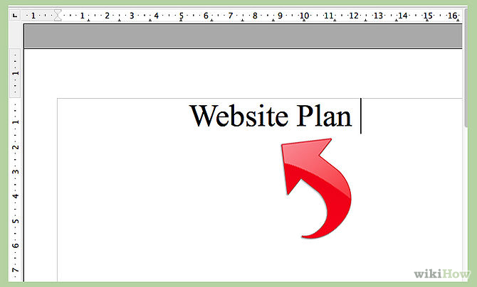

**THINK OF AN IDEA OR TOPIC**

* What do we want the site to be about?
* Who is our target audience?
* What information will our target audience need or want to know?

**THINK ABOUT YOUR SITE CONTENT**

* Make a list of all the pages to be included in your website
* Write the content for each page
* Convert documents that will be attached to the site (such as resumes, papers) to Adobe Acrobat PDF files
* Collect all pictures for the site
* Organize your files It may be helpful to create a folder for each page of the site and place the content and pictures in the appropriate folder.

**WEBSITE ARCHITECTURE**

* How will a visitor navigate through the pages of your site? Use a flow chart to design the navigational structure of your website
* Users should not have to click more than two times to find the desired information

**BENEFITS OF AN INTRANET WEBSITE**

* **Workforce productivity**: Intranets can help users to locate and view information faster and use applications relevant to their roles and responsibilities. With the help of a web browser interface, users can access data held in any database the organization wants to make available, anytime and — subject to security provisions — from anywhere within the company workstations, increasing employees' ability to perform their jobs faster, more accurately, and with confidence that they have the right information. It also helps to improve the services provided to the users.
* **Time:** Intranets allow organizations to distribute information to employees on an as-needed basis; Employees may link to relevant information at their convenience, rather than being distracted indiscriminately by email.
* **Communication:** Intranets can serve as powerful tools for communication within an organization, vertically strategic initiatives that have a global reach throughout the organization. The type of information that can easily be conveyed is the purpose of the initiative and what the initiative is aiming to achieve, who is driving the initiative, results achieved to date, and who to speak to for more information. By providing this information on the intranet, staff have the opportunity to keep up-to-date with the strategic focus of the organization. Some examples of communication would be chat, email, and/or blogs.

Web publishing allows cumbersome corporate knowledge to be maintained and easily accessed throughout the company using hypermedia and Web technologies. Examples include: employee manuals, benefits documents, company policies, business standards, news feeds, and even training, can be accessed using common Internet standards (Acrobat files, Flash files, CGI applications). Because each business unit can update the online copy of a document, the most recent version is usually available to employees using the intranet.

* **Business operations and management:** Intranets are also being used as a platform for developing and deploying applications to support business operations and decisions across the internetworked enterprise.
* **Cost-effective:** Users can view information and data via web-browser rather than maintaining physical documents such as procedure manuals, internal phone list and requisition forms. This can potentially save the business money on printing, duplicating documents, and the environment as well as document maintenance overhead.
* **Enhance collaboration**: Information is easily accessible by all authorized users, which enables teamwork.
* **Cross-platform capability**: Standards-compliant web browsers are available for Windows.
* **Built for one audience**: Since Intranets are user-specific (requiring database/network authentication prior to access), you know exactly who you are interfacing with and can personalize your Intranet based on role.
* **Promote common corporate culture**: Every user has the ability to view the same information within the Intranet.
* **Immediate updates:** When dealing with the public in any capacity, laws, specifications, and parameters can change. Intranets make it possible to provide your audience with "live" changes so they are kept up-to-date, which can limit a company's liability.
* **Supports a distributed computing architecture**: The intranet can also be linked to a company’s management information system, for example a time keeping system.

We will delivers information the way people want to receive it. Users can access it from anywhere, on their device of choice. One-on-One service level support. All our various modules can integrate with each other, your website and most other systems to allow for easy transitions and information sharing

The Intranet is placed on a live, secure server. This means it is always available to you, your employees and clients

Our modules have been built to the highest standards and are ready for use. This reduces development time and integration is quick and simple

You do not need to purchase the entire Intranet. You can choose the modules that you want to use

We will delivers information the way people want to receive it. Users can access it from anywhere, on their device of choice. One-on-One service level support. All our various modules can integrate with each other, your website and most other systems to allow for easy transitions and information sharing

**INTRANET USES**

* Intranets serve an organization’s digital communications needs. They also provide a secure space for storing, accessing and developing electronic materials.
* Some specific intranet applications include network folders where multiple employees can access the same files, offline websites that can be tested for functionality before going live, digital reference databases for looking up facts and figures, internal email systems and instant messaging software.

**THE INTRANET**

* is a network based on TCP/IP protocols belonging to an organization,
* accessible only by the organization's members, employees, or others with authorization

**ADVANTAGES OF AN INTRANET SITE**

|  |  |
| --- | --- |
| * Implementation benefits | * ◾Fast, easy, low-cost to implement * ◾Based on open standards * ◾Connectivity with other systems * ◾Many tools available * ◾Scalable |
| * Usability benefits | * ◾Easy to learn and use * ◾Multimedia * ◾Hypertext links * ◾Single interface to information resources and services |
| * Organizational benefits | * ◾Access to internal and external information * ◾Improves communication * ◾Increases collaboration and coordination * ◾Supports links with customers and partners * ◾Can capture and share knowledge |

In theory every employee could use the internet to get the same service. But for an intranet has the following advantages:

* Commercial or confidential data is kept secure within the organization
* Emails remain private ad may also be encrypted
* High bandwidth. No connection limits unlike the internet
* Reliable. The company will dedicate IT personnel to keep things running smoothly
* Information specifically tailored to the organization or staff’s needs can be published
* Intranet website represents your organization’s goals and culture on the intranet Homepage, for mobile and desktop.
* The homepage is a high- priority page on the majority of intranets because:
* Most employees are exposed to it when they launch their browsers
* It provides content importance to everyone
* It acts as a gateway to the rest of the resources on the intranet
* It can also direct employees to content that embodies the organization’s goals and culture

**DESIGN YOUR FIRST PAGE**

* [Choose the program(s) you will use to create your site](https://wiki.elon.edu/display/TECH/10+steps+to+effective+web+design+and+development#10StepstoEffectiveWebDesignandDevelopment-programs) based upon your skill level and needs
* If you choose a program that offers templates and themes:
* Choose a theme and color scheme
* Customize the theme and add your own pictures to make your page reflect your personality
* Organize your content so the most important areas are easily visible (Minimize scrolling and clicking)
* If you choose a program that requires your design expertise:
* Sketch out on paper a rough design for your page. A sketch will include areas for content, pictures, navigation, etc.
* Be creative, but keep it simple
* Organize your content so the most important areas are easily visible (Minimize scrolling and clicking)
* Determine your color scheme (Colors are very important. Pick a color scheme with a high contrast. Selecting the wrong colors may make it difficult for visitors to read your content.)
* Insert pictures to make your page reflect your personality. Images should enhance the look of a page, but it is not advisable to go overboard in stuffing your page with a truckload of images.

**LOOK AT YOUR FIRST PAGE**

* Is it likable to the eye and useful?
* Does it load quickly?
* Is it easy to navigate?
* Are your grammar and spelling correct?
* Do you have something people need or find useful?

**GET FEEDBACK**

Show your page to some friends or colleagues. They may notice something you missed.



**ESSENTIAL PURPOSES OF DESIGNING AN INTRANET SITE**

* Deliver Content
* Communication channel
* Collaboration: The intranet helps staff work together
* Culture: Intranet supports the organisational structure
* Activity: The intranet as a place of doing things
* Many people work in a remote locations, therefore it helps gives a sense of connectedness to the company as a whole regardless of where someone is located
* Another purpose of an intranet site is to share company information and computing resources among employees
* Intranet have been quite effective in keeping communication open with employees. We will then make the Cortex Hub page as a default start-up page from the browser which will make it easier for entrepreneurs to remember to log on for important information.

**THE WEB SITE DESIGN AND DEVELOPMENT PROCESS**

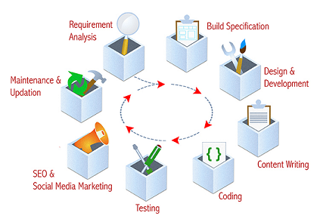

There are numerous steps in the web site design and development process. From gathering initial information, to the creation of your web site, and finally to maintenance to keep your web site up to date and current.

The exact process will vary slightly from designer to designer, but the basics are the same:

1. Information Gathering
2. Planning
3. Design
4. Development
5. Testing and Delivery
6. Maintenance

**PHASE ONE: INFORMATION GATHERING**



The first step in designing a successful web site is to gather information. Many things need to be taken into consideration when the look and feel of your site is created.

This first step is actually the most important one, as it involves a solid understanding of the company it is created for. It involves a good understanding of you – what your business goals and dreams are, and how the web can be utilized to help you achieve those goals

It is important to start off by asking a lot of questions to help understand your Organization and your needs in a web site.

Certain things to consider are:

**PURPOSE**

What is the purpose of the site? Do you want to provide information, promote a service, and sell a product…?

**GOALS**

What do you hope to accomplish by building this web site? Two of the more common goals are either to make money or share information.

**TARGET AUDIENCE**

Is there a specific group of people that will help you reach your goals? It is helpful to picture the “ideal” person you want to visit your web site. Consider their age, sex or interests – this will later help determine the best design style for your site.

**CONTENT**

What kind of information will the target audience be looking for on your site? Are they looking for specific information, a particular product or service, online ordering…?

**PHASE TWO: PLANNING**



Using the information gathered from phase one, it is time to put together a plan for your web site. This is the point where a site map is developed.

The site map is a list of all main topic areas of the site, as well as sub-topics, if applicable. This serves as a guide as to what content will be on the site, and is essential to developing a consistent, easy to understand navigational system. The end-user of the web site must be kept in mind when designing your site. These are, after all, the people who will be learning about your service or buying your product. A good user interface creates an easy to navigate web site, and is the basis for this.

During the planning phase, your web designer will also help you decide what technologies should be implemented. Elements such as what CMS (content management system) such as WordPress to incorporate, will any contact forms be needed, etc. are discussed when planning your web site.

**PHASE THREE: DESIGN**



Drawing from the information gathered up to this point, it’s time to determine the look and feel of your site.

Target audience is one of the key factors taken into consideration. A site aimed at teenagers, for example, will look much different than one meant for a financial institution. As part of the design phase, it is also important to incorporate elements such as the company logo or colors to help strengthen the identity of your company on the web site.

Your web designer will create one or more prototype designs for your web site. This is typically a .jpg image of what the final design will look like. Often times you will be sent an email with the mock-ups for your web site, while other designers take it a step further by giving you access to a secure area of their web site meant for customers to view work in progress.

Either way, your designer should allow you to view your project throughout the design and development stages. The most important reason for this is that it gives you the opportunity to express your likes and dislikes on the site design.

In this phase, communication between both you and your designer is crucial to ensure that the final web site will match your needs and taste. It is important that you work closely with your designer, exchanging ideas, until you arrive at the final design for your web site.

**PHASE FOUR: DEVELOPMENT**



The developmental stage is the point where the web site itself is created. At this time, your web designer will take all of the individual graphic elements from the prototype and use them to create the actual, functional site.

This is typically done by first developing the home page, followed by a “shell” for the interior pages. The shell serves as a template for the content pages of your site, as it contains the main navigational structure for the web site. Once the shell has been created, your designer will take your content and distribute it throughout the site, in the appropriate areas.

Elements such as the CMS (content management system) like WordPress, interactive contact forms, or ecommerce shopping carts are implemented and made functional during this phase, as well.

This entire time, your designer should continue to make your in-progress web site available to you for viewing, so that you can suggest any additional changes or corrections you would like to have done.

On the technical front, a successful web site requires an understanding of front-end web development. This involves writing valid HTML / CSS code that complies to current web standards, maximizing functionality, as well as accessibility for as large an audience as possible.

**PHASE FIVE: TESTING AND DELIVERY**



At this point, your web designer will attend to the final details and test your web site. They will test things such as the complete functionality of forms or other scripts, as well last testing for last minute compatibility issues (viewing differences between different web browsers), ensuring that your web site is optimized to be viewed properly in the most recent browser versions.

A good web designer is one who is well versed in current standards for web site design and development. The basic technologies currently used are HTML and CSS (Cascading Style Sheets). As part of testing, your designer should check to be sure that all of the code written for your web site validates. Valid code means that your site meets the current web development standards – this is helpful when checking for issues such as cross-browser compatibility as mentioned above.

Once you give your web designer final approval, it is time to deliver the site. An FTP (File Transfer Protocol) program is used to upload the web site files to your server. Some web designers offer domain name registration and web hosting services as well, or have recommendations as to where you can host your site. Once these accounts have been setup, and your web site uploaded to the server, the site should be put through one last run-through. This is just precautionary, to confirm that all files have been uploaded correctly, and that the site continues to be fully functional.

Other final details include plugin installation (for WordPress or other CMS driven web sites and SEO (Search Engine Optimization). SEO is the optimization of your web site with elements such as title, description and keyword tags which help your web site achieve higher rankings in the search engines. The previously mentioned code validation is something that plays a vital role in SEO, as well. There are many WordPress plugins available that further enhance the default WordPress functionality – many of which directly relate to improving your SEO, as well.

There are a lot of details involved in optimizing your web site for the search engines – enough to warrant its own post. This is a very important step, because even though you now have a web site, you need to make sure that people can find it!

**PHASE SIX: MAINTENANCE**



The development of your web site is not necessarily over, though. One way to bring repeat visitors to your site is to offer new content or products on a regular basis. Most web designers will be more than happy to continue working together with you, to update the information on your web site. Many designers offer maintenance packages at reduced rates, based on how often you anticipate making changes or additions to your web site.

If you prefer to be more hands on, and update your own content, there is something called a CMS (Content Management System) such as WordPress can be implemented to your web site? This is something that would be decided upon during the Planning stage. With a CMS, your designer will utilize online software to develop a database driven site for you.

A web site driven by a CMS gives you the ability to edit the content areas of the web site yourself. You are given access to a back-end administrative area, where you can use an online text editor (similar to a mini version of Microsoft Word). You’ll be able to edit existing content this way, or if you are feeling more adventurous, you can even add new pages and content yourself. The possibilities are endless!

It’s really up to you as far as how comfortable you feel with updating your own web site. Some people prefer to have all the control so that they can make updates to their own web site the minute they decide to do so. Others prefer to hand off the web site entirely, as they have enough tasks on-hand that are more important for them to handle directly.

That’s where the help of a your web designer comes in, once again, as they can take over the web site maintenance for you – one less thing for you to do is always a good thing in these busy times!

Other maintenance type items include regular site backups, WordPress upgrades, additional plugin installation, etc.

**AN EXAMPLE OF A WEBSITE**



**DOMAIN NAME INFORMATION**

The first thing you need to do when creating a website is to get your own domain name.

**WHAT IS A DOMAIN NAME?**

A domain name is your address on the web. It's the information that customers type in to find your website. It's what comes after the www. In www.domain.com. The domain name for our website is [*www.cortexhub.com*](http://www.cortexhub.com)

A domain name can be any combination of letters and/or numbers up to 63 characters. The official domain name extensions are .com, .net, .org, .biz, .info, .us and .ws.

**THE MAIN APPLICATIONS WE’D LIKE TO USE ON THE INTRANET IS:**

* News– Share and distribute company news.
* Document Management – Document collaboration with version control.
* Calendar – shared Company calendar.
* Company Social Networking – This application enables intranet users to post
* Comments and actively involves with colleagues.

**SECURITY**

We will keep all our staff contacts and conversations separate from their personal ones, securely in one place, across all the device in the hub.

Security doesn't seem to be such a major issue on a corporate intranet as it is on the public Internet. After all, this network is not public. But business considerations can make security an important issue with which to deal.

If security on an intranet is centralized, it is usually controlled by a corporate organization. Many corporations currently do not have centralized security for their intranets, which is unfortunate as much of the hacking done today occurs on private rather than public networks.

If your corporation does have central control of intranet security, those in charge will have security standards that your application must meet before you can place it on the intranet. As with other corporate organizations, you will probably have to plan in advance to work with the corporate security department. Some intranets might even use centrally administered security for logon passwords and other security issues.

[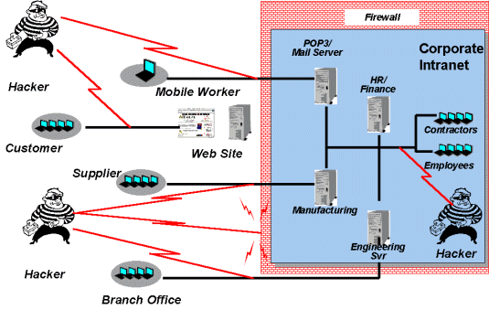](http://www.google.co.za/url?sa=i&rct=j&q=&esrc=s&source=images&cd=&cad=rja&uact=8&ved=0CAcQjRw&url=http://www.windowsecurity.com/whitepapers/misc/Guide_To_Securing_Intranet_And_Extranet_Servers.html&ei=KIZgVf3EF4KM7Qars4CoBw&bvm=bv.93990622,d.ZGU&psig=AFQjCNEMA2oojtiGpzYcABXQsgIr8zSZeg&ust=1432475552173516)

Most technicians find that security concerns often conflict with the technical considerations of their applications. Technical advances often outstrip the security department's ability to accommodate them. You might devote your time to security modules that seem overly burdensome and might find that you are unable to implement some technologies on the intranet because of security requirements and concerns. But by planning ahead, you can prepare time in your design and construction schedules to accommodate these security needs.

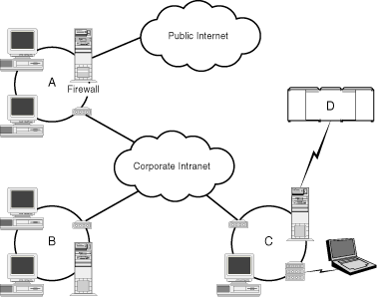

* **PROTECTING CONFIDENTIAL MATERIAL**

Another concern in intranet applications is protecting confidential material. It is true that your application is operating over corporate resources, but it can pass data that should not be seen by unauthorized employees, contractors, customers, and others who have access to the intranet. Many confidentiality issues discussed in Chapter 1 for the Internet also can be applied to intranet applications. Because the intranet and Internet are both TCP/IP networks, they have the same limitations and problems when plain text is transmitted across them.

One issue that requires a balancing act is the need for confidentiality versus the availability of information for the corporate community. Security and confidentiality issues are always cost-benefit trade-offs.

Remember also that you might have to apply local, state, and even national laws to the information in your application even though it passes over your private intranet. Personnel and financial applications are often subject to these laws. Another interesting consideration that spans political jurisdictions-states, provinces, or even countries-is that various segments of the intranet might be subject to different laws when it comes to the confidentiality of the information carried on them.

* **SECURITY VERSUS AVAILABILITY**

Maintaining security and confidentiality is a juggling act. On one side is the need to keep information secure and confidential, and on the other side is the need to make information available. There are no hard-and-fast rules for managing this dilemma. You could write an entire book on security and confidentiality issues. In a single chapter, I can provide only some guidelines by which you can develop your application.

You will need to examine two things to determine the level of security that your application requires. First, determine how sensitive your data is. Some data is easy. For example, if you are developing an organization chart application that will display information about your employees such as social security numbers, home addresses, and phone numbers, you are dealing with sensitive information that should be protected from unauthorized access.

Other information is more subtle. Let's say you're working on a marketing application that will enable your managers and sales representatives to share information about current and potential customers. You might think that this information doesn't need to be very tightly secured; after all, this is your internal network-your intranet. This brings us to the second consideration in the security versus availability dilemma.

Stop for a moment to consider the people who have access to your intranet.

Let's say you want to put your company newsletter online. Along with those announcements of company activities, the local bowling league scores, and the picture of the employee of the month is an article about your marketing strategy. If consultants, vendors, or customers had access to this information, it could give them (or their other customers) a competitive advantage in the future.

If your intranet has a mix of people on it, consider giving non-employees IDs that are easily identified, perhaps with special characters in certain positions. Secure all confidential or potentially damaging information with secured Web servers. Require access via ID and password. Your application can detect the special IDs and deny access to the information.

One interesting fact is that very few corporations have implemented internal firewalls on their intranets. You might consider implementing a firewall, especially if you are designing a sensitive divisional or departmental application that needs to be isolated from other divisions or departments.

How do you decide the security issues? Only you can do so. Look at the data, and then give some thought about the people who are using your intranet. If you have any doubt, secure the information. A few tips follow.

If you have any doubt about the security if your intranet, run your application on a secure server and pass information only to users with secure browsers to ensure that your sensitive information will not travel over your network as plain text.

Develop a central security system that can identify the various types of users by user ID and password.

Accept connections only from known, secure IP addresses. Make sure that machines that are accessible to unauthorized personnel cannot access your application. Use filters on your router, if appropriate, or refuse to send pages from your server to unknown IP addresses.

**CHANGE PASSWORDS PERIODICALLY**

Never send passwords via electronic mail unless the message is heavily encrypted. In fact, just to be safe, never send passwords through electronic mail, period!

Given a choice, most of us would select a password that was easy to remember, never change it, and use the same password everywhere. Your corporate security group probably has standards much stricter than that-for a reason. Easy passwords that never change are easy to crack, and once passwords are cracked, hackers can use them again and again.

If you must use passwords in your application, change them periodically. Once a month is typical, though your application might require more or less frequent changes. If you use the HTTP password capability, you will want a separate process for updating passwords. One way is to use corporate security files to obtain passwords. Another suggestion is to alter the passwords periodically yourself and distribute them to your users via a secure mechanism. Never send passwords in an electronic mail message unless the message is encrypted!

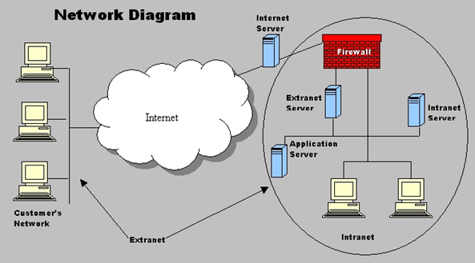

The Internet, extranets, and intranets all rely on the same TCP/IP technologies. However, they are different in terms of the levels of access they allow to various users inside and outside the organization and the size of the network. An intranet allows for restricted access to only members of an organization; an extranet expands that access by allowing non-members such as suppliers and customers to use company resources. The difference between the Internet and extranets is that while the extranet allows limited access to non-members of an organization, the Internet generally allows everyone to access all network resources.

Intranets are widely used across the world as means of sharing information among employees in businesses and/or development teams. Basically, an Intranet is a website running inside a company's LAN or WAN. They can be setup many different ways according to individual needs and budgets. The image below shows a diagram of a simple Intranet. 

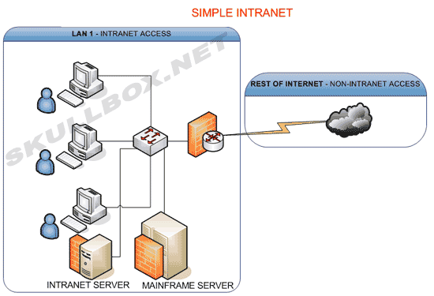

As you can see the entire LAN is behind a [firewall](http://www.skullbox.net/firewalls.php). A dedicated server is provided to run the Intranet. You might wonder why there is a mainframe server in the diagram. More technical organizations may integrate the Intranet with data from a mainframe server. While the two machines are not directly associated with each other, authenticated users may poses the ability to search a mainframe server using the company Intranet. These diagrams use industry standard schematic [symbols](http://www.skullbox.net/symbols.php).

**HOW TO CHOOSE A GOOD DOMAIN NAME**

Information and tips to help you select the best domain name:

**Keep it short**. The shorter, the better. It’s best to keep your domain name less than 15 characters if possible. A shorter name is easier for people to remember and it also reduces the likelihood that your visitor will mistype it or spell it wrong. For example, BuyIt.com has a lot less chance of being mistyped than isellthispleasebuyitfrommetoday.com.

**Keep it sweet**. The more memorable the name, the easier it is for people to remember. You can have the best site in the world, but if people can’t remember your domain name it will cut down on your return visitors. It’s hard enough to get traffic on the web without “losing” visitors that want to come back but can’t find you.

**Keep it simple.** Make sure the domain name is easy for people to spell. Don't spell words unusually. Unless you have incredible branding, people will type in the common spelling of your domain and your competition will get visitors who were looking for you.

**Choose a domain name that reflects your business.** Don’t just choose a random name. Choose a name that reflects your organization

When in doubt, choose a .com. If you are debating between several different domain names, go with the .com.

It’s what most people think of when they are typing in a domain name. It’s true the best names are gone, but you can still find a good .com if you look. Thousands of .coms expire and are released back in the market each month so there is always a steady supply of new domains coming into the market.

**Choose a Web Host**

Once you have your domain name, you will need to choose a web host. It is very important that you choose a good web host. Good doesn't mean expensive. Good means reliable with great support.

**WHAT IS A WEB HOST?**

A web host stores the web site you create on the server and transmits it to the internet so that when someone types in your domain name, your web site appears. A server is just a fancy computer that "serves up" your web site to the internet

**THINGS YOU WILL NEED**

* Notebook
* Computer
* Internet connection
* Website editing software
* Photo editing software
* Some knowledge on computer science (coding)

**TIPS ON MAKING YOUR WEBSITE MORE EFFECTIVE**

**Make your site social media friendly.**

Include social sharing links on every page of your nonprofit website. Encourage video and photo sharing, link to your social media profiles, and make it easy for bloggers and social networkers to embed your videos and feature your images on their sites and profiles. This will attract new traffic sources, retain visitors, and build community around your cause.

**Put your most compelling content front and center.**

If you have video or photos showing the work you do, use them! Strong imagery can help you build connections in a way that is not possible with words alone.

**Look at your website from the visitor's perspective.**

If you were a first-time visitor to your website, would you understand the mission of your organization? Are the actions you want a visitor to take clear? Is the navigation easy to understand? Surveys are a great way to gauge your site's usability and keep it dynamic in a universe that is always changing. Sites like Survey Monkey allow you to set up a survey that is simple and inexpensive.

**Email sign-up should be one of the most prominent items, and the easiest action for a visitor to take.**

If you don't have an email newsletter, you should. You can build your list and strengthen relationships by maintaining regular and meaningful contact with people who have already shown an interest in what you do. It's also easier to collect emails if you provide interesting content in return.

**Think about the home page description of your organization.**

If you only had ten words to describe yourselves, what would those words be? Make sure the words you use on your site are accurate and descriptive. It also helps if those words mirror the keywords and phrases people are likely to use searching for you or your issues.

**Prominently feature your 'Donate Now' button.**

Visitors shouldn't have to think about ways to engage with you - you need to show them how you want them to engage. Putting a Donate button on your site doesn't guarantee anyone will use it. But if you make a compelling case for your work, you should make it easy for visitors to support you.\

**Don't hide your address and phone number.**

Even in this high tech world, we still know that the best way to build a relationship is showing people that you're real. Phone numbers and addresses build trust and a sense of accessibility and is often the one piece of content people are looking for when they go to your site.

**Build and test your search function.**

A search function and site map is a quick and easy way to help users get to their destination as quickly as possible. Tools such as Google Analytics will tell you if users are finding what they need on your site.

**CONNECT TO YOUR BLOG.**

An organization's blog is an effective way to share your latest news and online engagement. Think of your blog as your website's little buddy. Only start a blog if you have something to say and are ready to make a commitment. If you aren't sure, try guest blogging for someone who already writes on similar topics. A blog also helps raise your ratings with search engines.

**INTRANET WITHIN AN ORGANIZATION**



[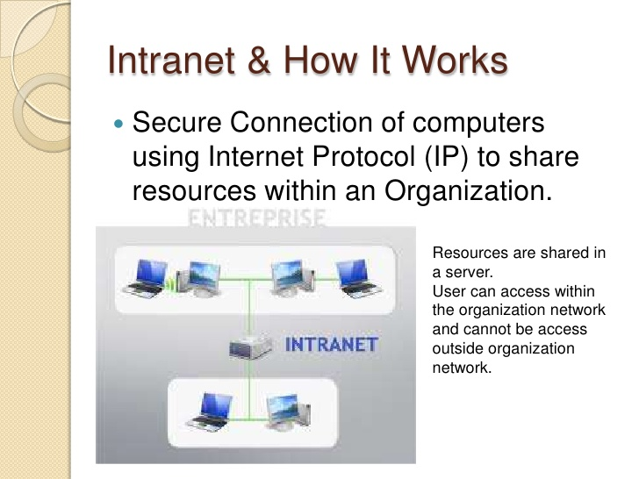](http://www.google.co.za/url?sa=i&rct=j&q=&esrc=s&source=images&cd=&cad=rja&uact=8&ved=0CAcQjRw&url=http://www.slideshare.net/CikguTgs/chap-3-network-intranet-internet&ei=pIZgVeT0NYfD7ga6-oCgAQ&bvm=bv.93990622,d.ZGU&psig=AFQjCNEMA2oojtiGpzYcABXQsgIr8zSZeg&ust=1432475552173516)

Intranet is the generic term for a collection of private computer networks within an organization. An intranet uses network technologies as a tool to facilitate communication between people or work groups to improve the data sharing capability and overall knowledge base of an organization's employees.

Intranets utilize standard network hardware and software technologies like Ethernet, Wi-Fi, TCP/IP, Web browsers and Web servers.An organization's intranet typically includes Internet access but is firewalled so that its computers cannot be reached directly from the outside.

Intranet is seen primarily as a corporate productivity tool. A simple intranet consists of an internal email system and perhaps a message board service. More sophisticated intranets include Web sites and databases containing company news, forms, and personnel information. Besides company email and Internet access, an intranet generally incorporates internal Web sites, documents, and/or databases.

**WARNINGS**

•Keep back-up copies of your website.

•Do not try to cheat Google using your Adsense account.

•Do not steal photos or content from other websites

**USABILITY AND ACCESSIBILITY**

You’ve got a good understanding of your target audience, you can start to look at the usability and accessibility aspects of your website.

* **Navigation**: Using all of your user research, create a navigation that is easy to use and satisfies the needs of your audience. Don't make people second-guess. Just keep the navigation really simple, clean and consistent.
* **Search:** Make sure your website has a search box to allow easy navigation. Sometimes you're own navigation isn't good enough, so create a search box to allow happy browsing.
* **Alt Attributes for Images:** If a web browser can't open an image, make sure there's an Alt attribute to describe what's there and even consider adding a caption.
* **Meaningful hyperlinks**: Good anchor text is a short summary that describes where a hyperlink will take a user once they click on it, so make sure you use anchor text that makes sense.
* **Consistent content:** Every web page on a successful website is meaningful and stays consistent to its message. Don't waffle and forget the focus of each web page. Stay on topic and present your content clearly and concisely.
* **Provide text versions of all audio and video content:** Not everyone has super-fast broadband, so provide text versions of any audio or video content - even if it's just a brief description about what the content is about. Also consider providing different formats for video and audio to give people options if they've got different bandwidths or software.
* **Organize pages consistently:** Keep your content, design and structure consistent throughout your entire website. Allow easy access to every other web page within your site at all times.
* **Avoid distractive features:** Pop-up windows, music and animation can be extremely annoying and off-putting. Keep usability focused by avoiding any irritating distractions that could just send your audience elsewhere.
* **Give users control:** A happy web visitor likes to be in control, so make sure your website helps people to feel in charge of your web pages. How you do this is by giving people the power to easily find things. If they come across something that's not there, make sure you have an error page to direct them back to where they want to be. If your website sells products online, allow your users to cancel, confirm or reverse an important action.
* **Create a Site Map:** Site Maps organize information, outlining the main topics covered in each web page. They allow people to quickly find what they're looking for. Create a Site Map and make sure all page titles link to the right pages.

**GETTING YOUR CONTENT RIGHT**

People browse the web for information, so it's crucial that you get your content right from the very start. Follow these next top tips and you'll be on the right track.

* **Structure your content**: When you first sit down and start to pull together the content for your website, it's best to write down a solid structure. You should already know what's going to be included, so create a document where you can easily write the content. For example, what's going on the home page? Are you including an 'about us' page? Also consider if you're including any images and pick out the ones you want to use.
* **Write for your audience**: When writing your content, always keep your audience in mind. Are they corporate? Write copy that suits a more professional audience by using formal language. Is your audience young and trendy? Write informal, conversational copy that holds their attention.
* **Keep your values in mind**: Some people end up writing content that shows no value. Remember, websites should build trust and credibility. Keep your company values in mind at all times and make sure you get them across in your copy.
* **Talk about what you love, not what you do**: People don't want to know what you do, they want to know what you're passionate about. Actually sit back and think about why you run your own business. What makes you happy? Tell people why you love what you do and they'll buy into your passion.
* **Throw in some SEO-friendly copy**: Never forget the search engines by writing copy that's SEO-friendly. What do I mean by this? Don't discount your keywords and write quality content that relates to those keywords. Give the crawler bots lots of juicy words to chew up. Just make sure your spelling and grammar is impeccable as search engines don't like sloppy language - and neither do your customers.
* **Don't boast too much**: A successful website gets across the company's values and achievements without boasting too much. Learn how to convey the right message so you don't over-boast but still show what you're good at.
* **Stay on topic**: It's easy to forget what you're writing about when you start drafting content for any particular web page. Stay on topic by writing a title and always reminding yourself about that title. So if you find yourself losing focus, go back to your title to stay on track.
* **Show some personality**: Don't come across all stiff and boring by being too 'corporate'. Do show your personality because people are just people. Show that you're human by adding some personality to your web copy wherever possible.
* **Add testimonials**: Nothing adds credibility more than a recommendation from one of your existing customers. Make sure you add testimonials to your website to offer trust and reassurance to new visitors.
* **Show off your work**: Your website is a perfect opportunity to show people what you're good at. Add a portfolio or case studies to show where you've helped others and really made a difference.

**SEARCH ENGINE OPTIMIZATION**

Search Engine Optimization, or 'SEO' for short, is the art of helping a website perform better in the Search Engine Results Pages or 'SERPs'. That's those results pages that come up whenever you type something into the search engines. If you want to appear higher in those listings, this is where SEO comes into play.

**Consider your keywords**: Keywords are those words that help search engines to establish what your website is about. They're the words and phrases that people might type into Google or Bing to land on your site. Research your keywords and then structure your site and its content around them.

**Meta Titles**: Meta Titles are those titles you see come up in the search engine results pages. Add your own Meta Titles to your website and ensure you include your keywords. A top tip with Meta Titles is to put your most important keyword at the very start. And keep them less than 70 characters long - the shorter, the better. Also - make sure your Titles are different on every single web page within your site.

**Meta Descriptions**: Meta Descriptions help to describe what your web page is about. Add no more than 155 characters and don't forget to repeat your keywords.

**Meta Keywords**: Add your keywords along with anything else that helps to describe your website.

**Headers:** Add your keywords to the most important header tag or 'H1' tag on your web page. Use headings in a semantic, logical manner and both humans and search engines will love you for it.

**SEO-friendly copy:** When you draft your content, keep your keywords in mind at all times and write copy that relates to those keywords. A top tip is to keep your spelling and grammar spot on.

**Image Alt Tags**: make sure you add 'Alt Tags' to images using your keywords or something to describe that image.

**Bold & Italic**: Highlight some keywords and phrases by adding bold or italic styling to them. Google will see these highlighted words as important. Use sparingly though. You only need to do this three-four times on each web page.

**Fresh content**: Search engines love fresh content. Keep your website fresh by writing a regular blog. The more you update your website, the more Google or Bing will come back to index your web pages. The more they do that, the more your SEO will be boosted.

**Don't go mad**: When optimizing your website, it's easy to forget the design and litter pages with bolded and italic copy. This can end up looking messy and off-putting. Always keep a good balance to avoid alienating either your audience or the search engines

As internet usage continues to grow, largely due to the exploding growth of smartphones and tablets.

**TIPS TO DESIGNING AN OUTSTANDING WEBSITE:**

* **Know your objectives.**

The first step is to determine the purpose of your website and what you want your end users to do. Do you want to create interaction? Content consumption? E-commerce? Define the goals for your website and structure the design and content accordingly.

* **Stand out.**

There is a lot of noise on the internet and it is up to you to grab your customer’s attention. How are you going to be different, better and be remembered? Be creative find interesting ways to convey your content, find your own voice and create a website design that grabs attention.

* **Call things by their name.**

Usability is about making things easy for your users. Make your site intuitive and call things by their name. Buttons and call to actions should say exactly what you want the user to do join, click, enter, etc. You have a finite time to capture your customer's attention. Unless you give a clear direction, the user will learn little about you.

* **Interfaces are not for interpretation.**

Don't sacrifice usability in the name of originality. Make your interface user friendly and organize your content so it can easily be found. You work hard to get traffic to your site keep users consuming your content by quickly leading them to the content that interests them.

* **Create websites for the worst bandwidth connections.**

Not everyone has a powerful computer or a 12 MB internet connection. Design a site that can be easily opened and viewed by the worse connection.

* **Prioritize content before beginning the design phase.**

Make a list of your content and prioritize it from most to least important. This simple exercise will help you eliminate content that you really don't need and saves you from designing pages that are not as useful as you originally thought.

* **Create functional wireframes.**

Make sure you know what your site is going to look like and how it is going to work.

* **Make your website design mobile friendly.**

According to some statistics, more people will access the internet via mobile than desktop within the next three years. When designing your site, make sure you have a mobile-optimized version.

AN EXAMPLE OF A SECURE INTRANET

[](http://www.google.co.za/url?sa=i&rct=j&q=&esrc=s&source=images&cd=&cad=rja&uact=8&ved=0CAcQjRw&url=http://www.windowsecurity.com/whitepapers/misc/Guide_To_Securing_Intranet_And_Extranet_Servers.html&ei=KIZgVf3EF4KM7Qars4CoBw&bvm=bv.93990622,d.ZGU&psig=AFQjCNEMA2oojtiGpzYcABXQsgIr8zSZeg&ust=1432475552173516)